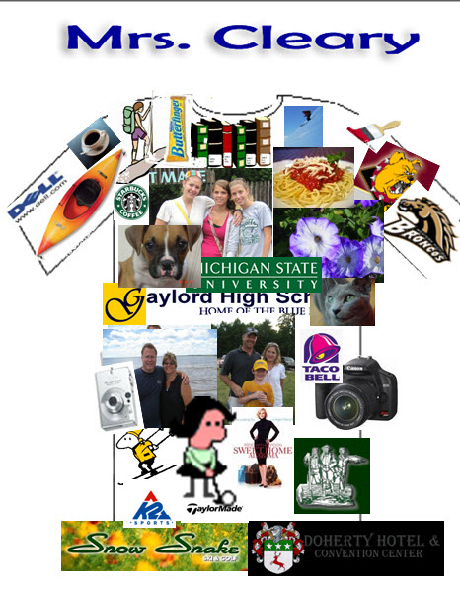
Name: ___________________________________________Hour _________

Introduction sentence: __________________________________________________________

100% | 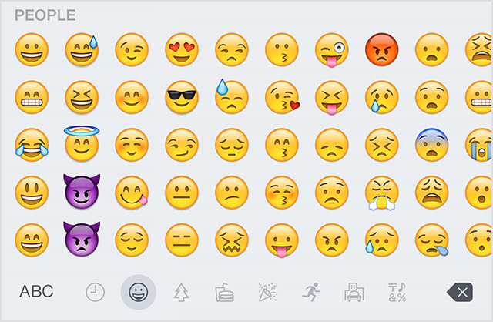 |  |  |  | 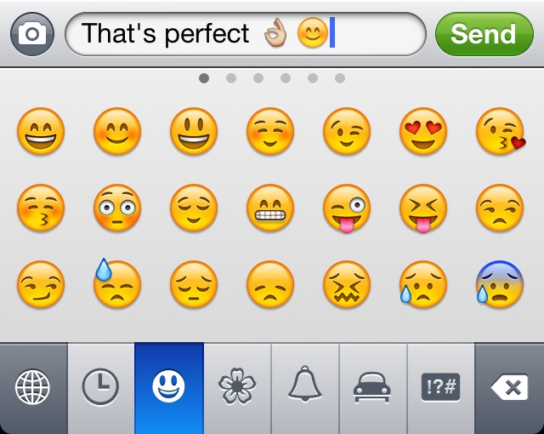 |  |  |  | 
10 | 9 | 8 | 7 | 6 | 5 | 4 | 3 | 2 | 1

20 images that tell about you.
100%
10 | 9 | 8 | 7 | 6 | 5 | 4 | 3 | 2 | 1

All images are cropped and arranged neatly & “G” rated.
100%
10 | 9 | 8 | 7 | 6 | 5 | 4 | 3 | 2 | 1

Presentation: Includes a nice loud voice, eye contact and NO verbal junk (do not say um, stuff, like, etc.)
100%
10 | 9 | 8 | 7 | 6 | 5 | 4 | 3 | 2 | 1

Total _________/40

